Report findings about the data

Few Sample Images from the dataset:
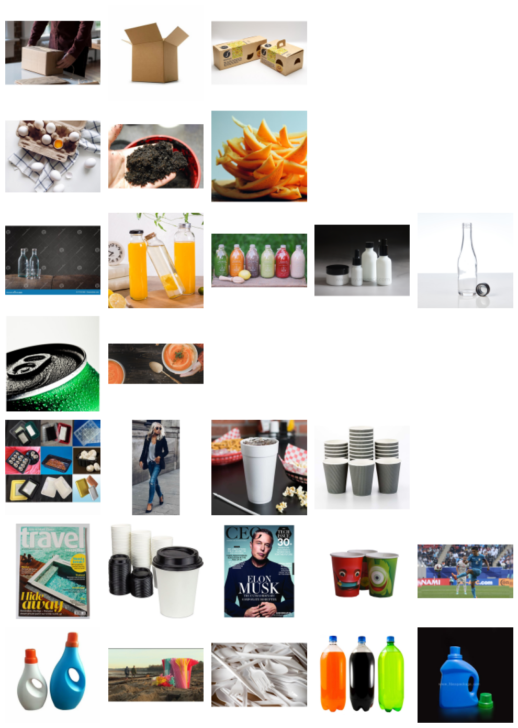

Class Distribution explains total images w.r.t classes:
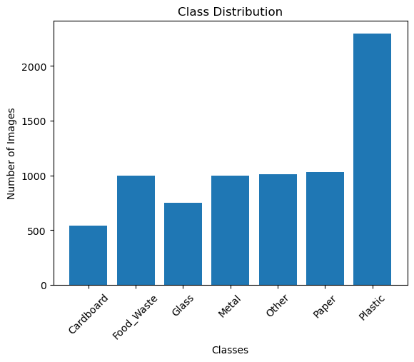
- Data was initially of 256x256 size.
- Post the data processing, Data encoding was applied on the labels

2. Report Model Training Results
CNN Model was developed using 3 Convolutional Layers. Below is the Model Summary:
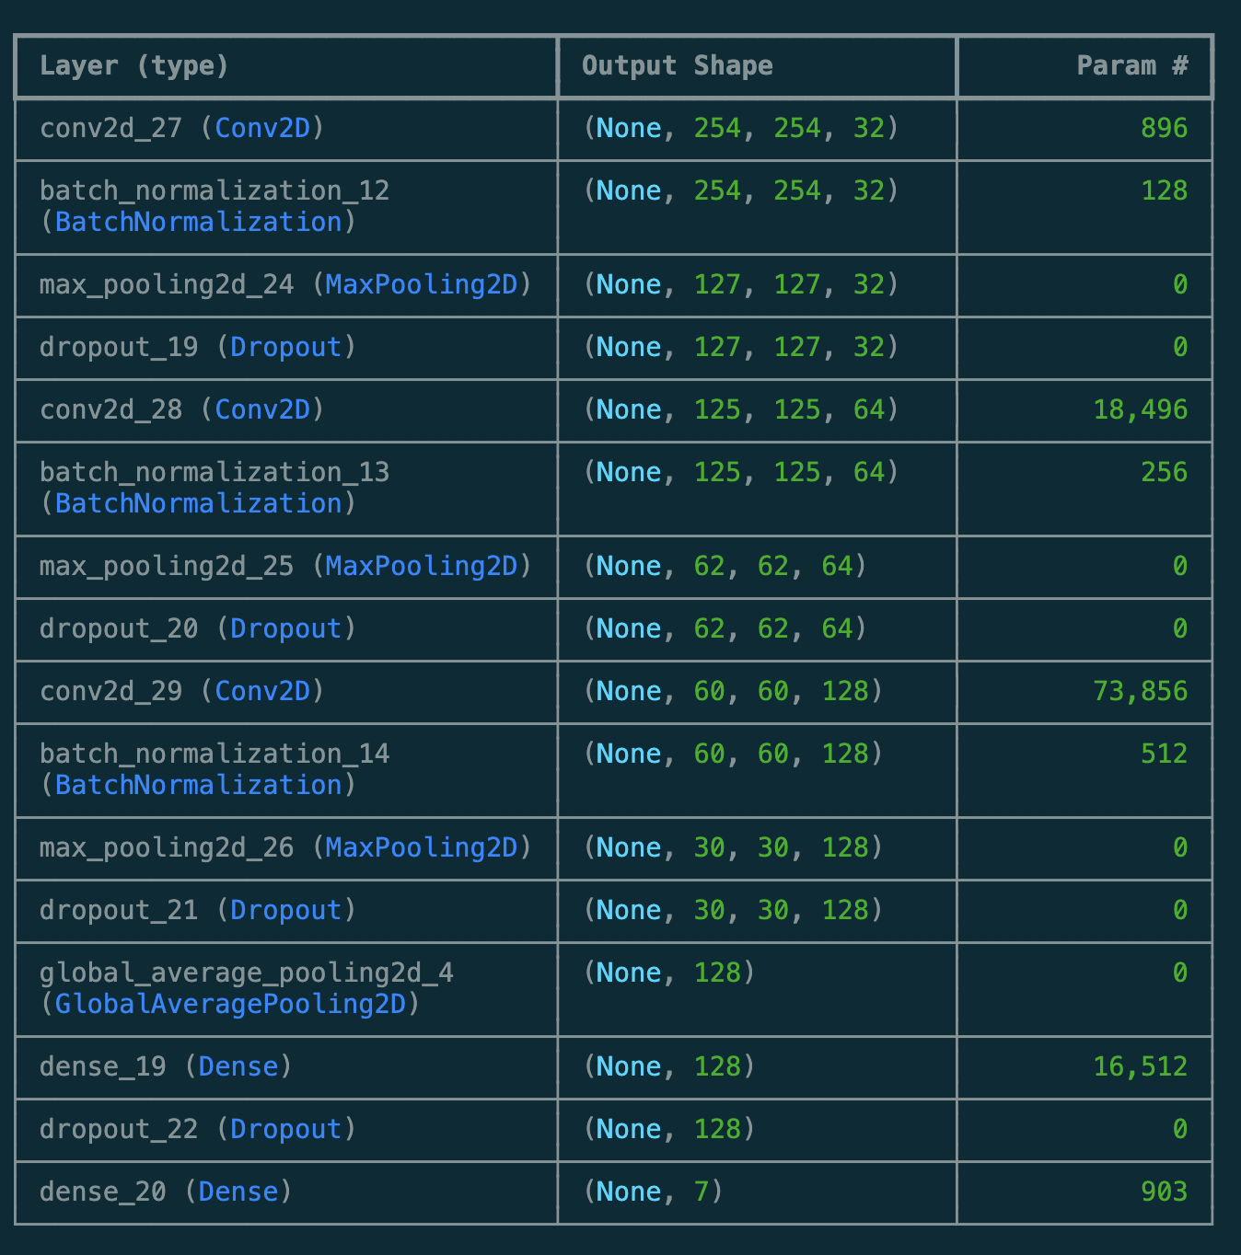
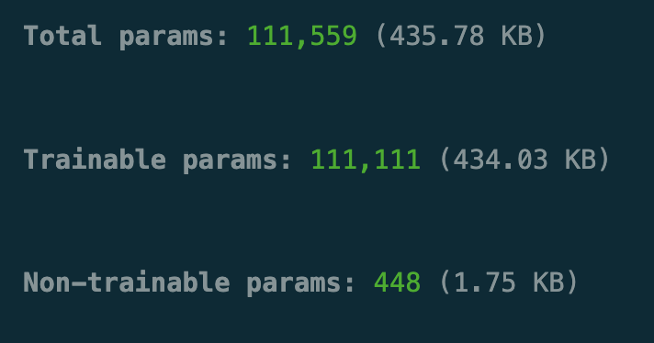
Model Training:
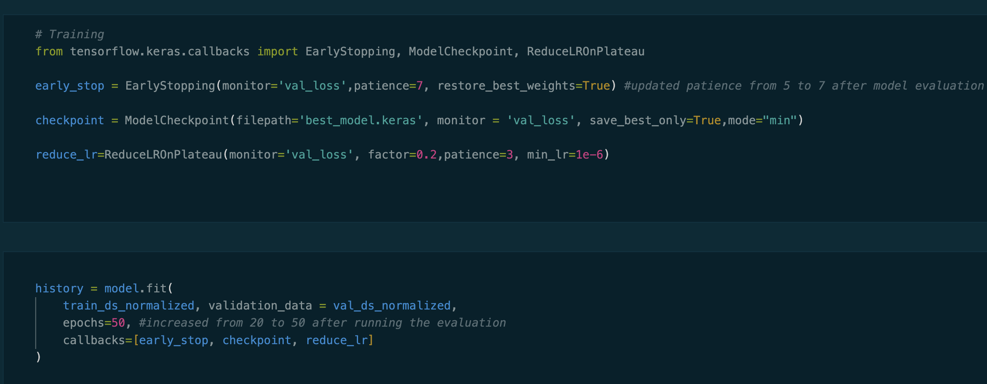
After training the model for the 1st time, I observed that it will need more patience and more iterations than 20. So, updated model has patience as 7 (previously 5) and epochs as 50 (previously 25)

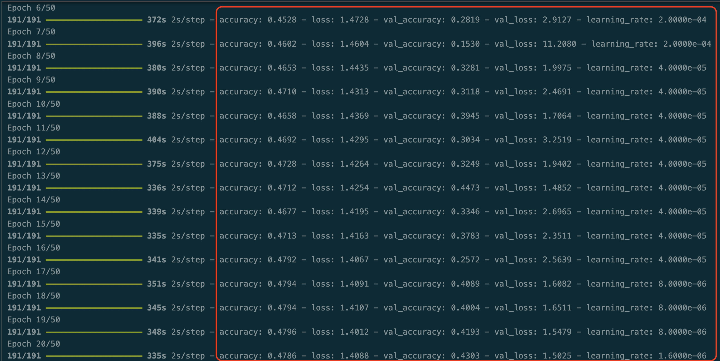

Model Validation gave the Accuracy of 44% and loss of 1.48 which is not a good model. We will have to further tune the model via transfer learning which is not in scope of this Assignment.
